**ARTIFACTS TO SUBMIT**

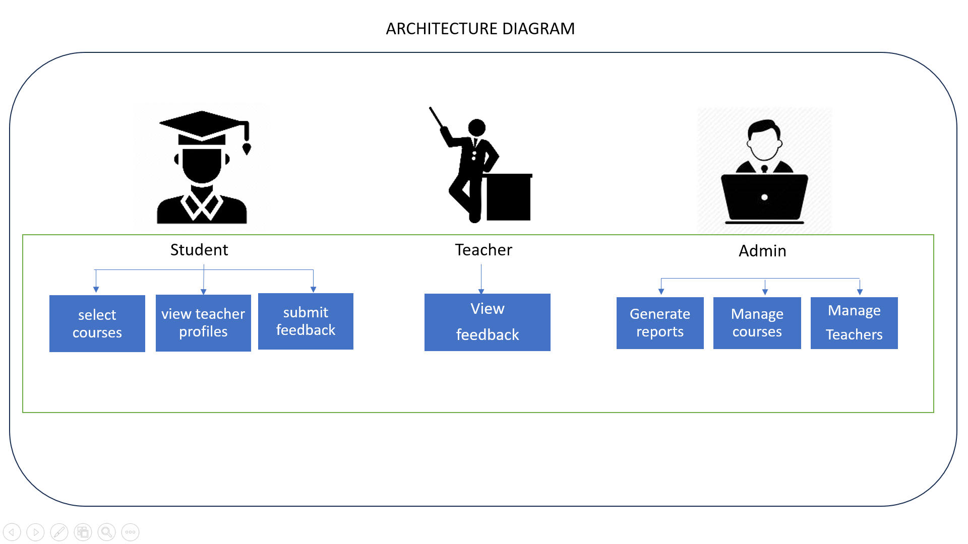

**SOFTWARE TOOLS**

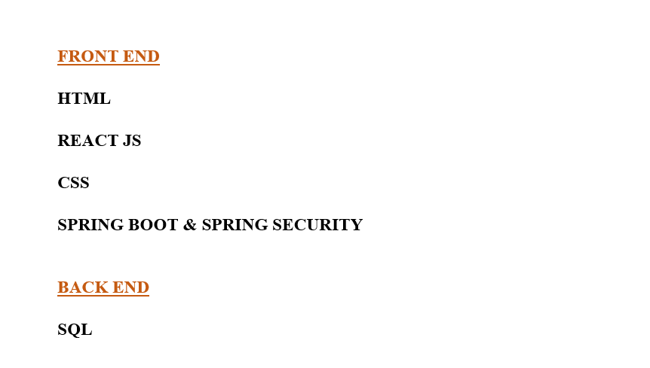

**STEP BY STEP PROCEDURE**

